ISLAMIC UNIVERSITY OF TECHNOLOGY

Organization of Islamic Cooperation

Board Bazar, Gazipur

Mid-Semester Lab Exam

CSE 4512

## IP Addresses of Hosts

Question: What is the IP address of PC1 of the subnetwork “Network1”?

Answer: 172.20.29.2

Question: What is the default gateway address of PC1 of the subnetwork “Network1”?

Answer: 172.20.29.1

Question: What is the IP address of PC2 of the subnetwork “Network1”?

Answer: 172.20.29.3

Question: What is the default gateway address of PC2 of the subnetwork “Network1”?

Answer: 172.20.29.1

Question: What is the IP address of PC3 of the subnetwork “Network2”?

Answer: 10.10.29.2

Question: What is the default gateway address of PC3 of the subnetwork “Network2”?

Answer: 10.10.29.1

Question: What is the IP address of PC4 of the subnetwork “Network2”?

Answer: 10.10.29.3

Question: What is the default gateway address of PC4 of the subnetwork “Network2”?

Answer: 10.10.29.1

Question: What is the IP address of PC5 of the subnetwork “Network3”?

Answer: 192.168.29.2

Question: What is the default gateway address of PC5 of the subnetwork “Network3”?

Answer: 192.168.29.1

Question: What is the IP address of PC6 of the subnetwork “Network3”?

Answer: 192.168.29.3

Question: What is the default gateway address of PC6 of the subnetwork “Network3”?

Answer: 192.168.29.1

## IP Addresses of the interfaces of the Routers

Question: What is the IP address of the interface “serial0/1/0” of the Core Router?

Answer: 200.200.20.1

Question: What is the IP address of the interface “serial0/1/1” of the Core Router?

Answer: 200.200.20.5

Question: What is the IP address of the interface “serial0/2/0” of the Core Router?

Answer: 200.200.20.9

Question: What is the IP address of the interface “serial0/2/1” of the Core Router?

Answer: Not Used

Question: What is the IP address of the interface “serial0/1/0” of Router0 of the subnetwork “Network1”?

Answer: 200.200.20.2

Question: What is the IP address of the interface “serial0/1/1” of Router0 of the subnetwork “Network1”?

Answer: Not Used

Question: What is the IP address of the interface “serial0/2/0” of Router0 of the subnetwork “Network1”?

Answer: Not Used

Question: What is the IP address of the interface “serial0/2/1” of Router0 of the subnetwork “Network1”?

Answer: Not Used

Question: What is the IP address of the interface “serial0/1/0” of Router1 of the subnetwork “Network2”?

Answer: 200.200.20.6

Question: What is the IP address of the interface “serial0/1/1” of Router1 of the subnetwork “Network2”?

Answer: Not Used

Question: What is the IP address of the interface “serial0/2/0” of Router1 of the subnetwork “Network2”?

Answer: Not Used

Question: What is the IP address of the interface “serial0/2/1” of Router1 of the subnetwork “Network2”?

Answer: Not Used

Question: What is the IP address of the interface “serial0/1/0” of Router2 of the subnetwork “Network3”?

Answer: 200.200.20.10

Question: What is the IP address of the interface “serial0/1/1” of Router2 of the subnetwork “Network3”?

Answer: Not Used

Question: What is the IP address of the interface “serial0/2/0” of Router2 of the subnetwork “Network3”?

Answer: Not Used

Question: What is the IP address of the interface “serial0/2/1” of Router2 of the subnetwork “Network3”?

Answer: Not Used

Question: What is the Router ID of the router “Router2” of the subnetwork “Network3” after the configuration of OSPF routing?

Answer: 200.200.20.10

## Screenshot of the routing table of the Routers

Question: Add a screenshot of the routing table of Router0 of the subnetwork “Network1”.

Answer:

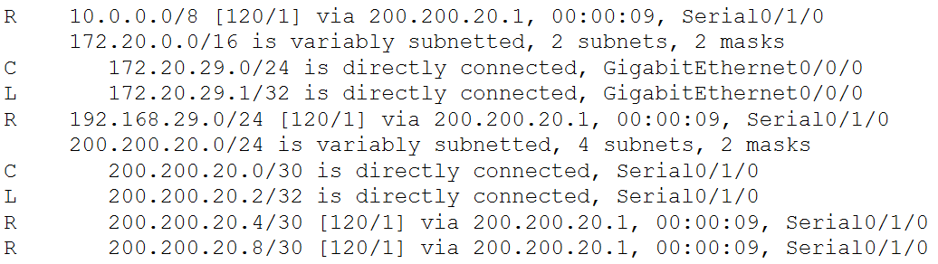

Question: Add a screenshot of the routing table of Router1 of the subnetwork “Network2”.

Answer:

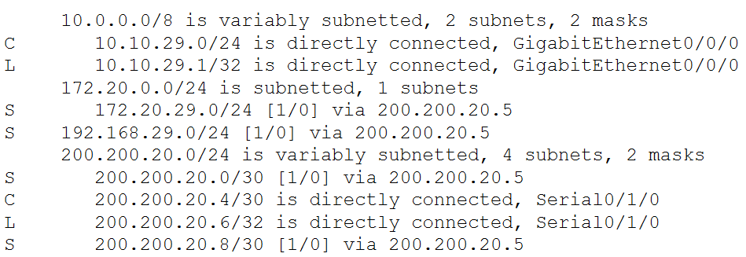

Question: Add a screenshot of the routing table of Router2 of the subnetwork “Network3”.

Answer:

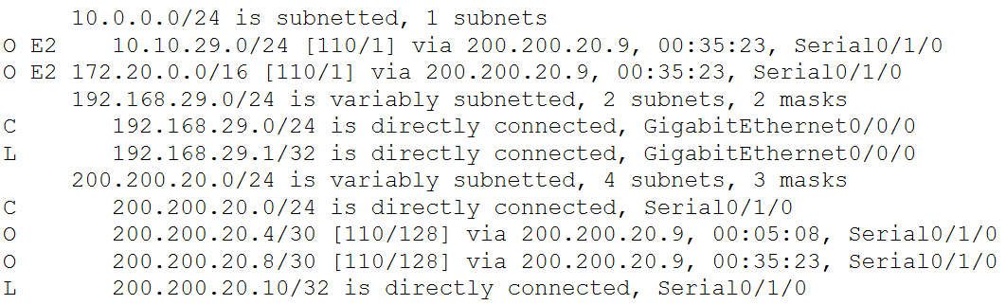

Question: Add a screenshot of the routing table of the Core Router.

Answer:

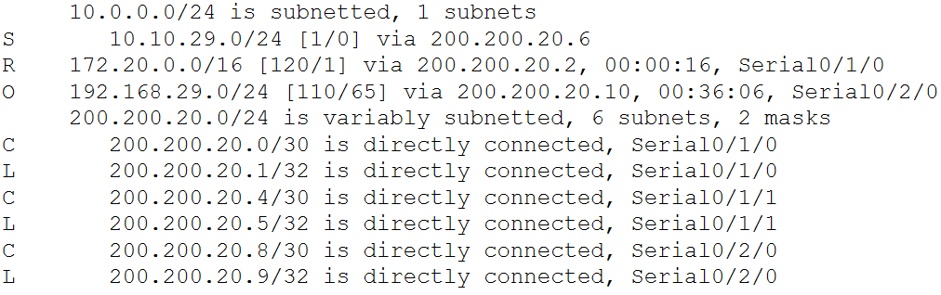

Question: Add a screenshot of the complete topology with proper labelling after configuration.

Answer:

